**Pre-Quiz**

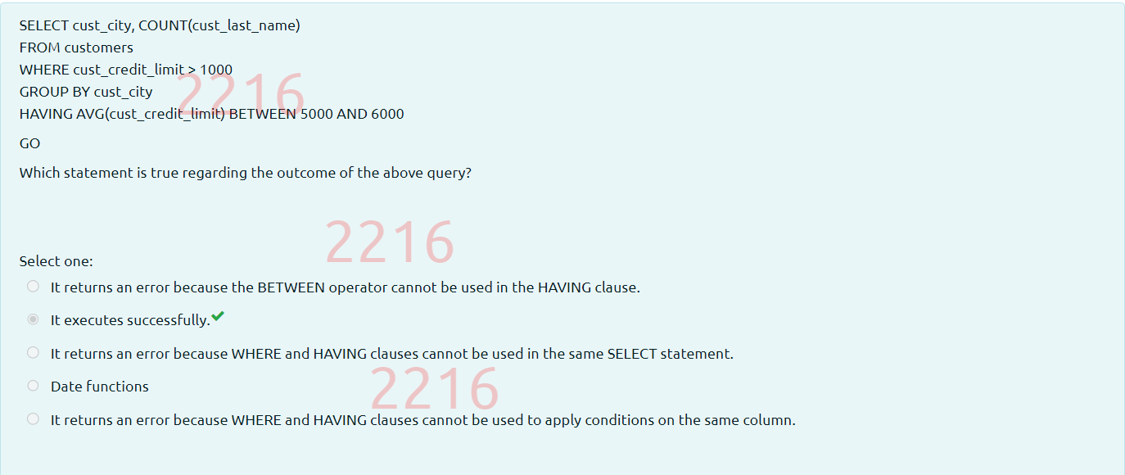

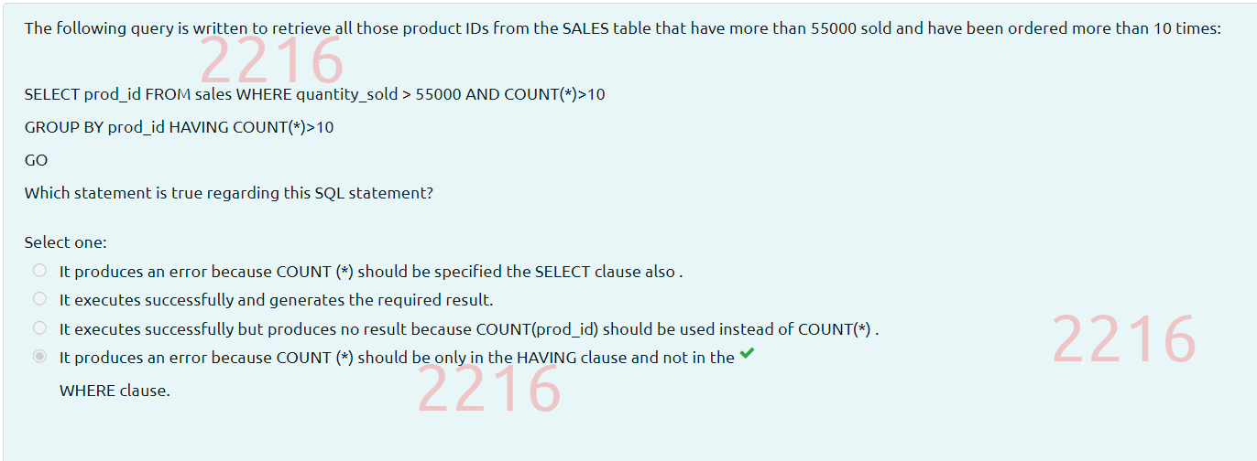

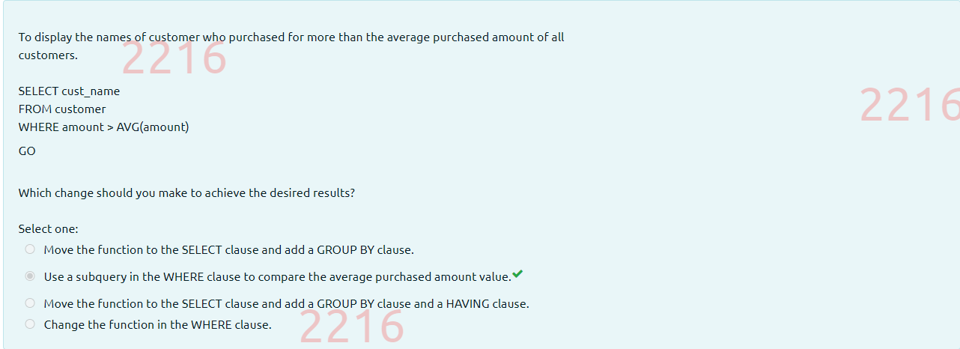

**Post-Quiz**



